|  |  |
| --- | --- |
| D:\Webdev\Profile\images\AWS-Cert.jpg D:\Webdev\Profile\images\google.jpg D:\Webdev\Profile\images\PMI-PMPLOGO.png D:\Webdev\Profile\images\msft.png | **Aswin Kumar**  **Email id:** [**aswinkumar86@hotmail.com**](mailto:aswinkumar86@hotmail.com)  **Mobile No:- +91 9940154041**  **Website:-** [**https://aswinkumar.blob.core.windows.net/profile/index.html**](https://aswinkumar.blob.core.windows.net/profile/index.html) |
|  |  |

**Professional Experience**

1. **Accenture as SSE from MAY 2012 to Sept 2014.**
2. **Wipro Technologies as SSE from Nov 2007 to Apr 2012.**

**Certifications:**

*1. PMI-PMP (Project Management Professional)*

*2. AWS-CSAA (Certified Solutions Architect Associate)*

*3. AWS- Sysops Administrator Associate.*

*4. Microsoft Azure Implementing Microsoft Azure Infrastructure Solution.*

*5. Google Cloud Platform.*

**Notable Mentions:**

1. Hosted websites for Corporate, Profiles, e-commerce and word press blogs using cloud platforms.
2. Managed 25 member team for a Real Estate start-up.
3. Experience in Agile, Kanban and Multi cloud deployments.

**My Work -Git Repo:**

1. Website’s :- <https://github.com/Aswinkumar6/Websites>
2. Azure DSC Configurations:- <https://github.com/Aswinkumar6/DSC-Configuration>
3. Azure ARM Templates:- <https://github.com/Aswinkumar6/AZURE>
4. AWS :- <https://github.com/Aswinkumar6/AWS>

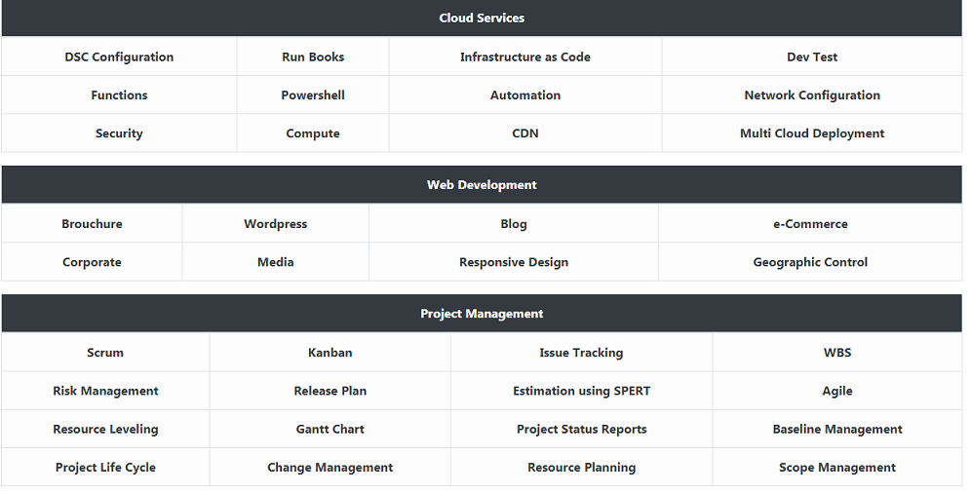

**Skills**

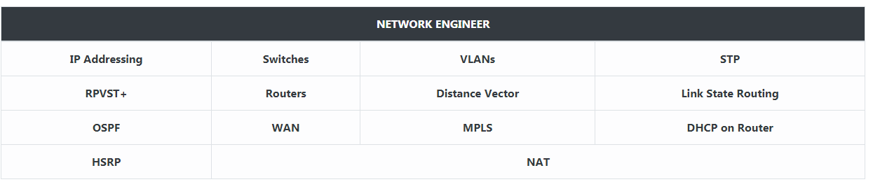

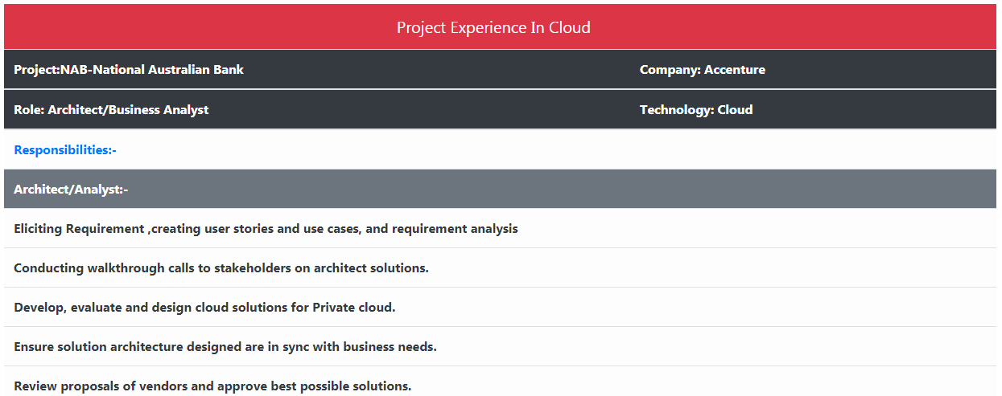 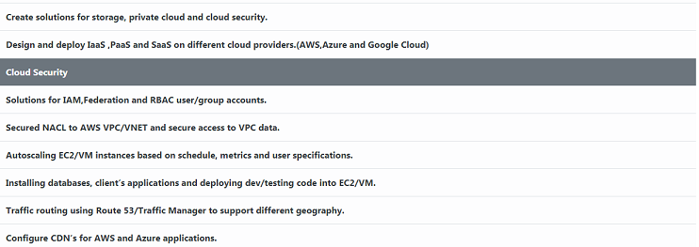

**Project Experience:**

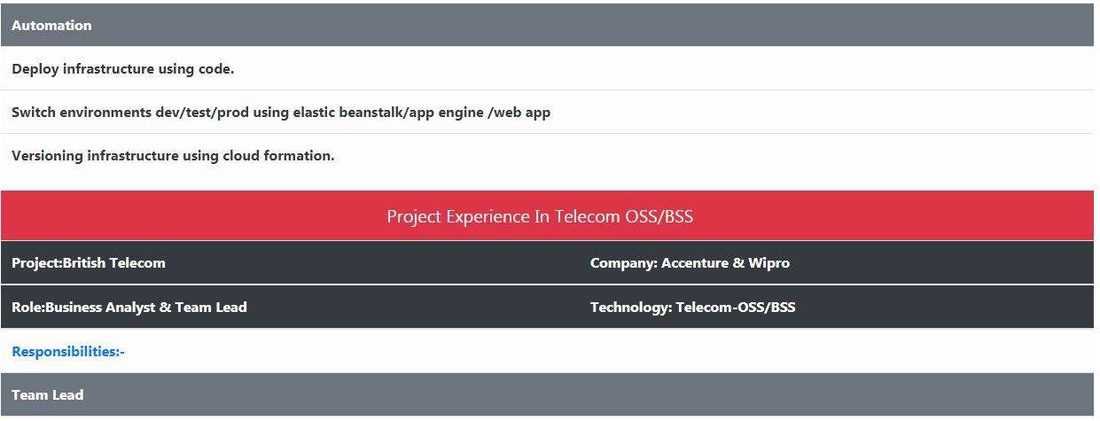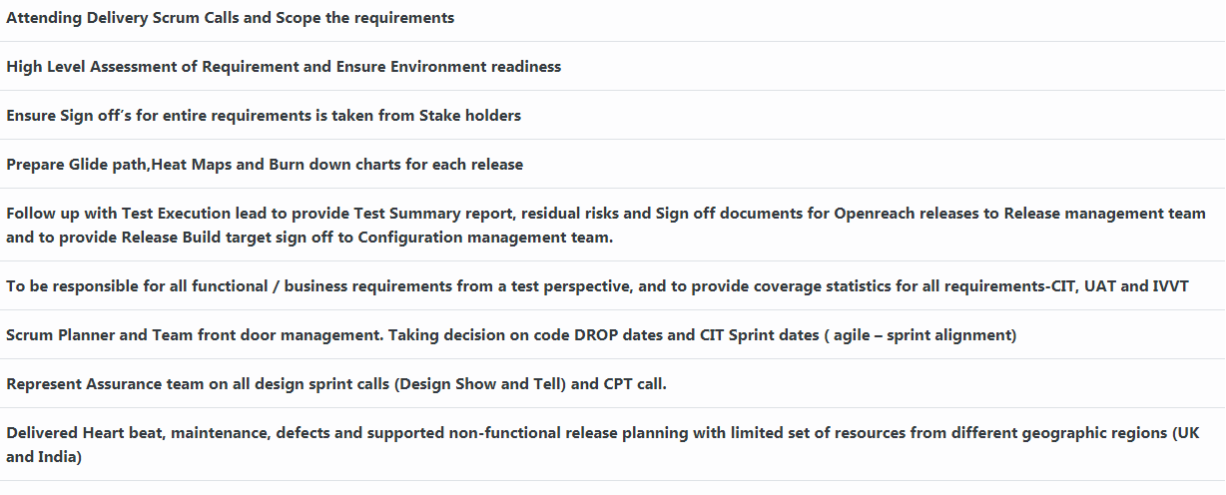

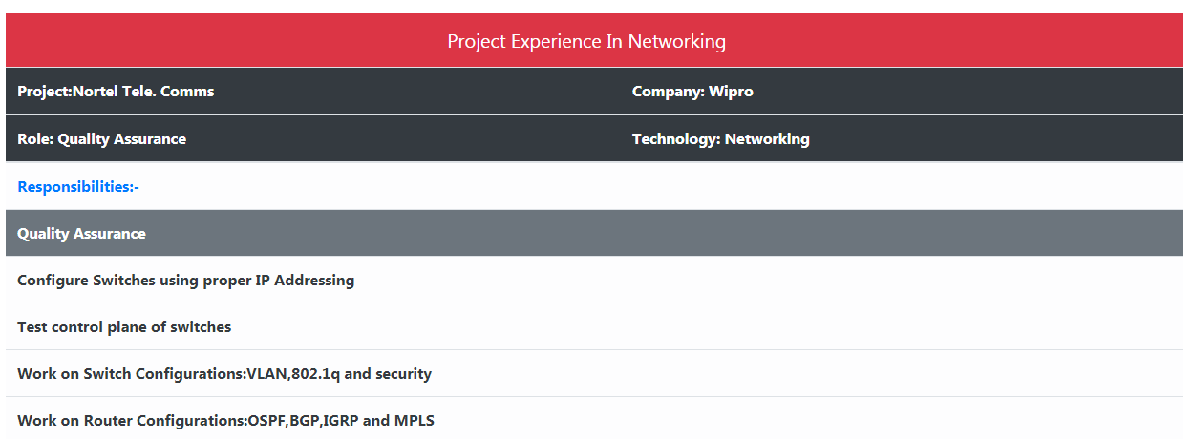

**Education:**

|  |  |  |
| --- | --- | --- |
| **Grade** | **School/College** | **Percentage** |
| SSC | Loyola High School | 83% |
| Higher Secondary | Gautami Dhamam Jr. College | 87.4% |
| B.E | Anna University | 77% |